- Internship Name : Data Analysis
- Task Name: Task 7:
- Your Name : Shubhangi Naresh Khonde
- Internship Organization :
- Date:

1.Introduction:
Pandas is an open-source Python library used for data analysis and manipulation. It provides two main data structures, Series (one-dimensional) and DataFrame (two-dimensional, table-like). In this task, I worked with these structures and used basic functions to explore and understand a dataset.

2. Objectives:
- To understand and create a Pandas Series
- To create a Pandas DataFrame from a dictionary
- To view data using head()
- To understand the dataset structure using info()
- To get statistical summaries using describe()

3. Tools and Technologies Used:
- Language: Python 3.13
- Library: Pandas
- Environment: Jupyter Notebook

4. Methodology and Implementation:
Step 1: Importing the Library
I imported the Pandas library using import pandas as pd.
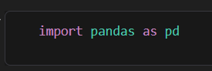

Step 2: Creating a Pandas Series
A Series is a one-dimensional labeled array. I created a Series of student marks: [75, 82, 68, 90, 85]. Pandas automatically assigned index values 0 to 4, and the data type was int64.
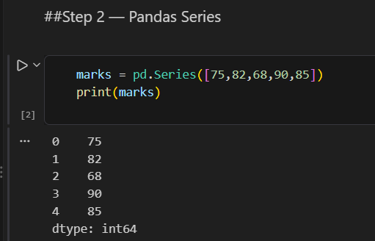

Step 3: Creating a Pandas DataFrame
A DataFrame is a two-dimensional table with rows and columns. I created one from a Python dictionary containing student records with four columns:
Column | Description
Name | Student name
Age | Student age
Marks | Marks obtained
City | City of the student

The DataFrame had 5 records (Amit, Priya, Rahul, Sneha, Neha).

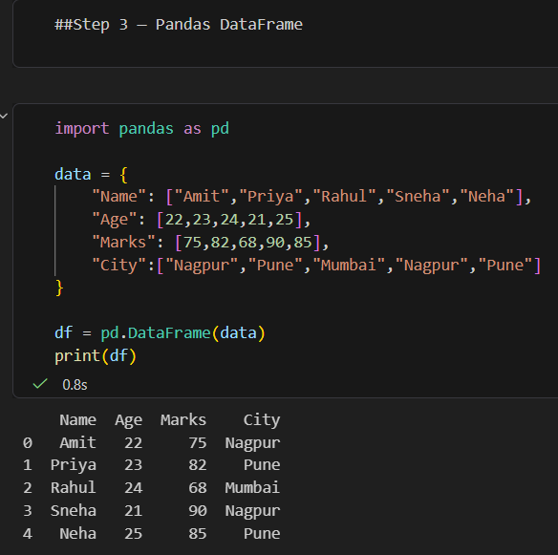

Step 4: Using the head() Function:
- df.head() displays the first 5 rows by default.
- df.head(3) displays only the first 3 rows.
This is useful for quickly previewing a large dataset without printing everything.

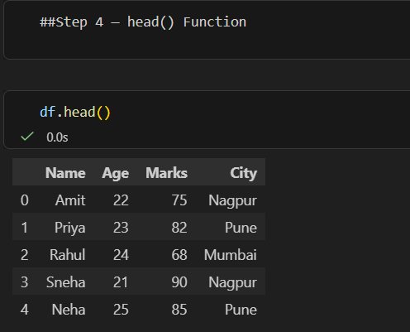

Step 5: Using the info() Function
df.info() gives a concise summary of the DataFrame. The output showed:
- The DataFrame has 5 entries (RangeIndex 0 to 4) and 4 columns
- No missing values (all columns have 5 non-null entries)
- Data types: Age and Marks are int64; Name and City are string type
- Memory usage: 292 bytes
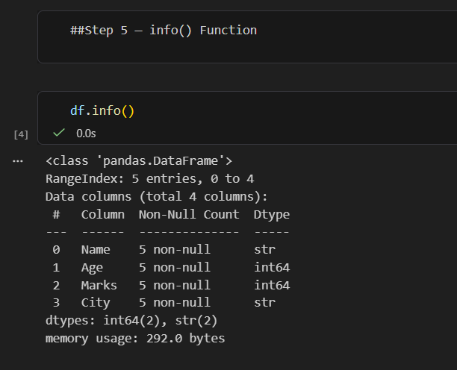
Step 6: Using the describe() Function
For numerical columns (df.describe()):

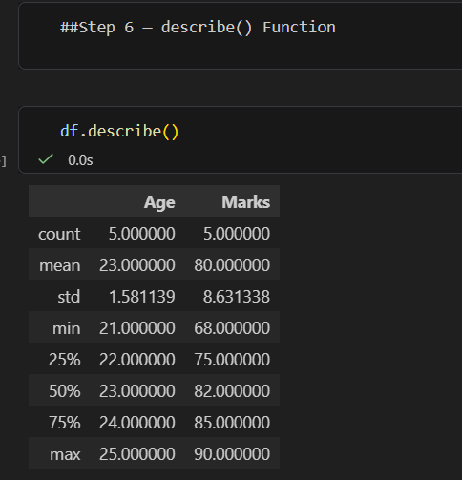

- Name: 5 unique values, each appearing once
- City: 3 unique values (Nagpur, Pune, Mumbai); the most frequent is Nagpur (2 times)
5. Observations:
- The average marks of the students is 80, and the average age is 23 years.
- The highest marks are 90 (Sneha) and the lowest are 68 (Rahul).
- The dataset has no missing values, so no data cleaning was required.
- Nagpur and Pune each have 2 students, and Mumbai has 1.
- A deprecation warning appeared when using include="object" in the newer Pandas version, because text columns now use the str dtype. In future versions, include="str" should be used instead.

6. Challenges Faced:
- Understanding the difference between a Series and a DataFrame
- Handling the Pandas deprecation warning for describe(include="object")

7. Learning Outcomes:
- I learned how to create and work with Pandas Series and DataFrames.
- I learned how to quickly inspect a dataset using head(), info() and describe().
- I understood how to read basic statistics such as mean, median, standard deviation, and quartiles.
- I gained a foundation for data analysis, which is useful for further tasks such as data cleaning, filtering, and visualization.

8. Conclusion:
This task gave me practical, hands-on experience with the fundamentals of Pandas. By creating a Series and a DataFrame and applying head(), info() and describe(), I learned how to load, inspect, and summarize data. These skills are the first step in any data analysis workflow.

